2013 ACE Critique and Awards Program
NMSU Media Productions — Jeanne Gleason

Demographica –  An iPhone/iPad App  Class 39  Innovative use of  communication technology | 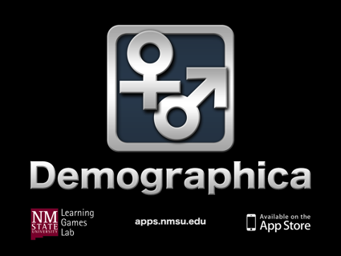
To look at a video demonstrating this project, visit ACE.nmsu.edu/2013/College/Class39Demogr.html
This link also offers screen shots from this iPhone/iPad app.
The Need and the Audience:
Attempting to gather demographic information in a noisy room full of community members is a risk-taking exercise in itself, and most Extension educators would prefer to bypass the task. But gathering demographic information at every public meeting is also a Federal requirement for many USDA programs, such as county Extension educational meetings and 4-H activities. Imagine you’re an Extension educator, trying to set up the meeting room, welcome participants, and coordinate the educational activities. Then you remember you also must make three accurate counts of all participants – by sex, age, and ethnicity. Gathering accurate and timely demographic data about program participants is a huge problem for Extension and many other organizations required to make reports on every meeting.
Although other states have proposed various paper forms and online computer systems in an attempt to make data collection easier, these options have proven too time consuming, and were often completed so far after the event that there were doubts about their accuracy.
Purpose (goals, objectives):
In 2012, NMSU’s Media Productions decided to tackle this problem. The team realized that the solution had to be highly portable, extremely easy to use, and offer instant submission of the demographic information to the university database without needing to transfer the data to another spreadsheet or reporting system. The possibility of an iPhone/iPad app met with the most enthusiasm from the Extension educators. These mobile devices are becoming more common among the educators. Agents said that to be successful, the app would need to support gathering information in less than five minutes, require only one click per person, and file the report instantly without any more hassle.
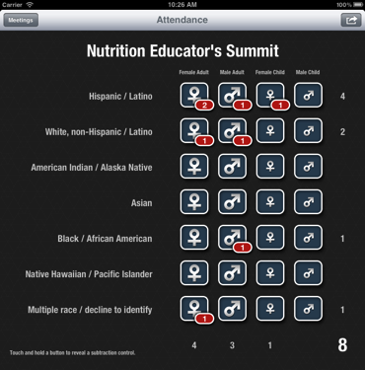
The Innovation:

Demographica was Media Productions’ innovative response to these needs and demands from the Extension educators and agents.
- It uses the Federal ethnicity categories and age groups most commonly reported by Extension agents.
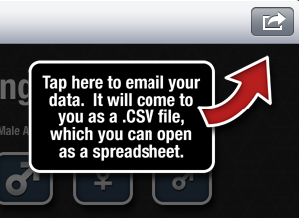
- It allows an almost instant tally with the touch of a finger on an iPad or a thumb on an iPhone, including instant and easy correction of mistakes.
- With only one finger tap, an agent can report all of the three key demographic requirements – ethnicity, sex, and age group.
- Much to the delight of the agents, they can simply tap one button, and the mobile device transforms their data into a .cvs file, copies the meeting title and date into an email, and instantly sends the data to the university’s data reporting system.
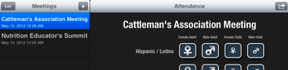
- At the request of the formative evaluation team of Extension agents, Demographica was also enhanced to allow agents to easily set up and store demographic data for a number of meetings at the same time. They could also easily change the title of a meeting if they made a mistake.

Marketing/promotion:
Demographica received pre-release promotion at the Fall National eXtension meeting and will be introduced to the NM Extension Statewide Conference at the spring 2013 annual meeting. It is currently on the Apple App Store, and several other states are considering adopting Demographica.
Role of each entrant for the project:
All work, including programming, art, and instructional design, was produced in NMSU’s Media Productions studios. The specific team for Demographica is listed in its credits.
Extent to which project met goals and objectives:
Each feature of Demographica was pilot tested during development, and the agents report this app will solve many of their data-gathering headaches. NMSU is committed to upgrades and enhancements.
How diversity was incorporated into entry:
New Mexico’s overall population is 47% Hispanic and 10% Native American, and the state is often considered a bellwether for future demographic changes across the United States. Documenting the multicultural richness of Extension’s clientele is an important goal for NMSU Extension. This app makes that task much easier and more accurate. Further, it supports civil rights reporting at NMSU and other similar institutions.

